The Camel Corps was part of the expedition dispatched to relieve General Gordon who was besieged by the Dervish Army at Khartoum. The column was under the command of Sir Garnet Wolseley. After defeating the Mahdists at Abu Klea, the column arrived within sight of Khartoum, only to find they were too late: the city had fallen two days earlier, and Gordon and the garrison had been massacred.
This figure represents a private from the 1st Battalion Grenadier Guards. He wears a tunic of grey serge and Bedford cord breeches with blue puttees. His weapon is the Martini Henry rifle and he has been issued with the 'Yakatan' sword bayonet especially for this expedition. The bandolier holds fifty rounds of ammunition and his goggles are tinted blue to protect his eyes from the glare of the desert sun.
He's almost entirely scratch built apart from the obvious bits of equipment. The body is one of the older Hot Toys figures with a repainted and moustachioed Dragon head. Boots are from the Russell Franklyn figure. His Pvt Williams canteen has been modified following Pierre Turner's illustrations. Thanks to Tony for the parts to improve the Martini Henry and for the buckles on display here.
Also a big thankyou to Mpcdock who very kindly sent me a bag of bits that included some of the leather and the eyelets that have been used here. I also paid more than a few visits to Mark's Camel Corps figure he entered into the competition earlier this year.
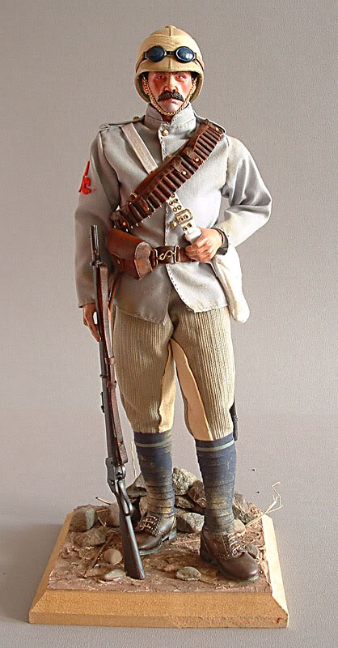Also a big thankyou to Mpcdock who very kindly sent me a bag of bits that included some of the leather and the eyelets that have been used here. I also paid more than a few visits to Mark's Camel Corps figure he entered into the competition earlier this year.
